**SQL Assessment Test 2**

**Questions and Expected Results**

Keep in mind there is usually more than one way to answer these questions. For the solutions you can visit this link:

<https://docs.google.com/document/d/1swGZ0RG3KKqWqzmsI_qrMgjJ3lt39mtAJqRSMZy6Z-8/edit?usp=sharing>

OR you can watch the solutions video walkthrough lecture.

These questions start off with the basics and then get continually more difficult.

1. How can you retrieve all the information from the cd.facilities table?
   * **Expected Result should look similar to this (with more rows):**

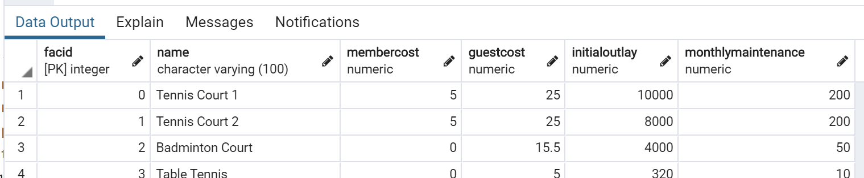

**SELECT * FROM cd.facilities**

1. You want to print out a list of all of the facilities and their cost to members. How would you retrieve a list of only facility names and costs?

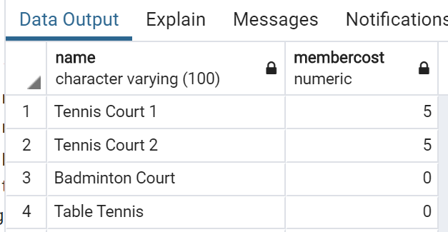

**SELECT name,member cost FROM cd.facilities**

1. How can you produce a list of facilities that charge a fee to members?
   * Expected Results should have just 5 rows:
   * 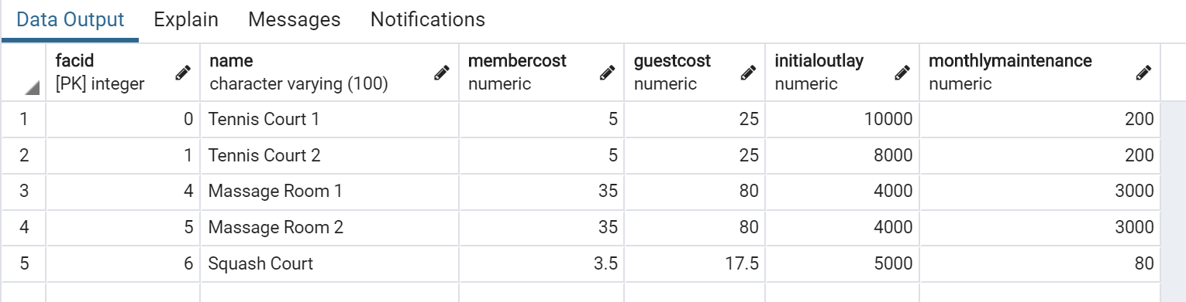

**SELECT * FROM cd.facilities**

**WHERE membercost > 0**

1. How can you produce a list of facilities that charge a fee to members, and that fee is less than 1/50th of the monthly maintenance cost? Return the facid, facility name, member cost, and monthly maintenance of the facilities in question.
   * Result is just two rows:

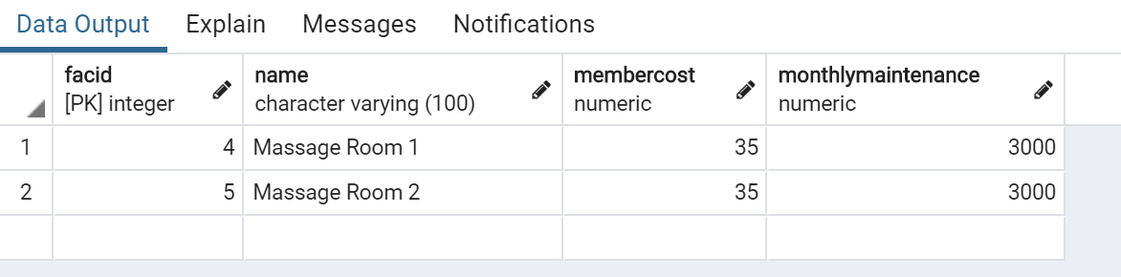

**SELECT faced,name,membercost,monthlymaintenance**

**FROM cd.facilities**

**WHERE membercost > 0 AND membercost < (monthlymaintenance/50)**

1. How can you produce a list of all facilities with the word 'Tennis' in their name?
   * **Expected Result is 3 rows**
   * 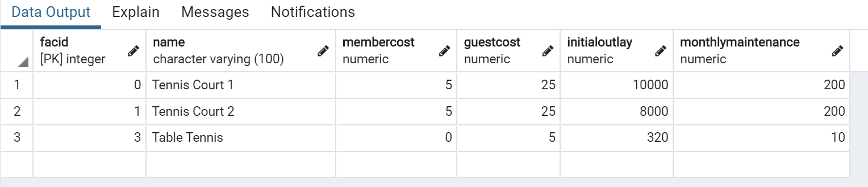

**SELECT * FROM cd.facilities**

**WHERE name LIKE ‘%tennis%’**

1. How can you retrieve the details of facilities with ID 1 and 5? Try to do it without using the OR operator.
   * **Expected Result is 2 rows**
   * 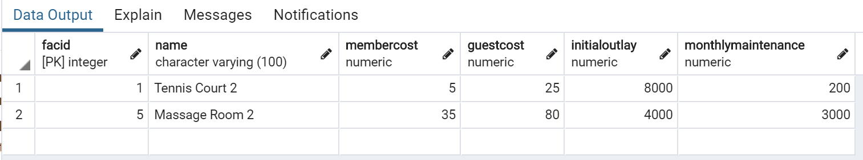

**SELECT * FROM cd.facilities**

**WHERE faced IN (1,5)**

1. How can you produce a list of members who joined after the start of September 2012? Return the memid, surname, firstname, and joindate of the members in question.
   * **Expected Result is 10 rows (not all are shown below)**
   * 

**SELECT Mimi’s,surname,first name,join date FROM cd.members**

**WHERE joindate > ‘2012-09-01 00:00:00’**

1. How can you produce an ordered list of the first 10 surnames in the members table? The list must not contain duplicates.
   * **Expected Result should be 10 rows if you include GUEST as a last name**
   * 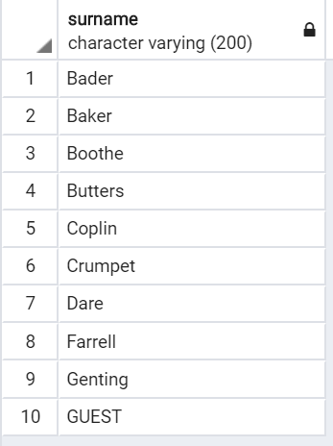

**SELECT DISTINCT(surname) FROM cd.members**

**ORDER BY surname**

**LIMIT 10**

1. You'd like to get the signup date of your last member. How can you retrieve this information?
   * **Expected Result**
   * **2012-09-26 18:08:45**

**SELECT MAX(joindate) FROM cd.members**

1. Produce a count of the number of facilities that have a cost to guests of 10 or more.
   * **Expected Result**
   * **6**

**SELECT COUNT(guest cost) FROM cd.facilities**

**WHERE guestcost >= 10**

1. Produce a list of the total number of slots booked per facility in the month of September 2012. Produce an output table consisting of facility id and slots, sorted by the number of slots.
   * **Expected Result is 9 rows**
   * 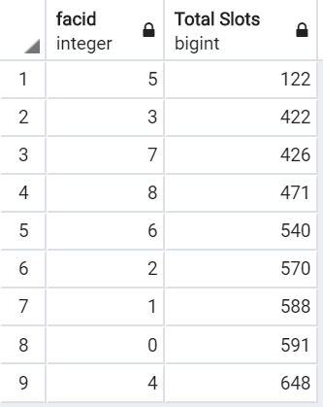

**SELECT DISTINCT(facid),SUM(slots) AS “Total Slots” FROM cd.bookings**

**WHERE starttime BETWEEN ‘2012-09-01’ AND ‘2012-09-30’**

**GROUP BY facid**

**ORDER BY SUM(slots)**

1. Produce a list of facilities with more than 1000 slots booked. Produce an output table consisting of facility id and total slots, sorted by facility id.
   * **Expected Result is 5 rows**
   * 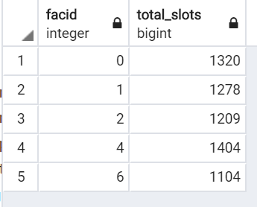

**SELECT facid,SUM(slots) AS “total_slots” FROM cd.bookings**

**GROUP BY facid HAVING SUM(slots) > 1000**

**ORDER BY facid**

1. How can you produce a list of the start times for bookings for tennis courts, for the date '2012-09-21'? Return a list of start time and facility name pairings, ordered by the time.
   * **Expected Result is 12 rows**
   * 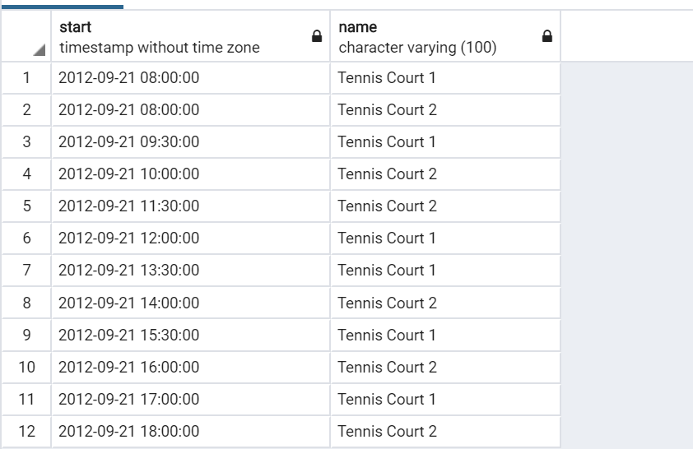

**SELECT starttime AS start, cd.facilities.name AS name from cd.bookings**

**LEFT JOIN cd.facilities**

**ON cd.facilities.facid = cd.bookings.facid**

**WHERE cd.facilities.name LIKE ‘TENNIS%’ and starttime BETWEEN ‘2012-09-21 00:00:00’ AND ‘2012-09-21 24:00:00’**

**GROUP BY starttime, cd.facilities.name**

**ORDER BY starttime**

1. How can you produce a list of the start times for bookings by members named 'David Farrell'?
   * **Expected result is 34 rows of timestamps**

**SELECT DISTINCT(starttime) FROM cd.bookings**

**LEFT JOIN cd.members**

**ON cd.members.first name = ‘David’ AND cd.members.surname = ‘Farrell’**

**GROUP BY starttime**